CMPE277

My Tube application

**CMPE277 Screenshots**

**Login Screen**:

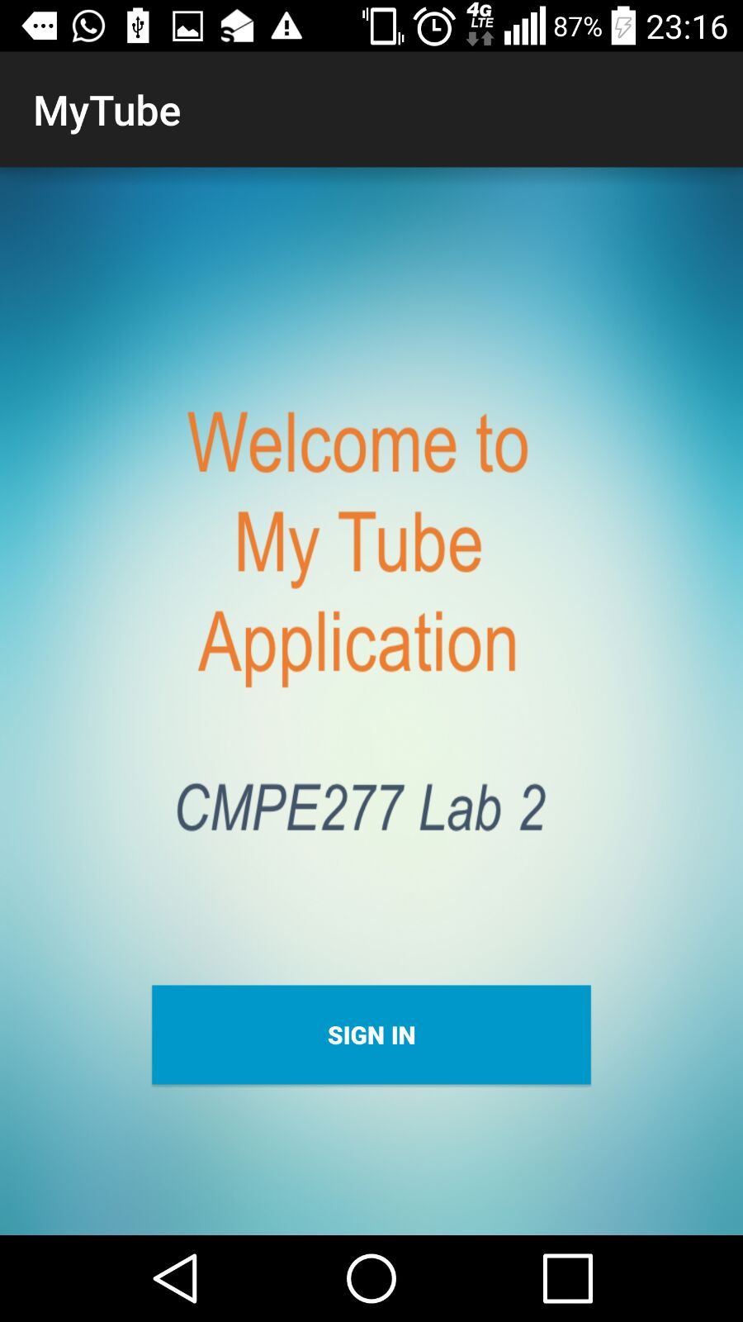

Sign in Screen  
 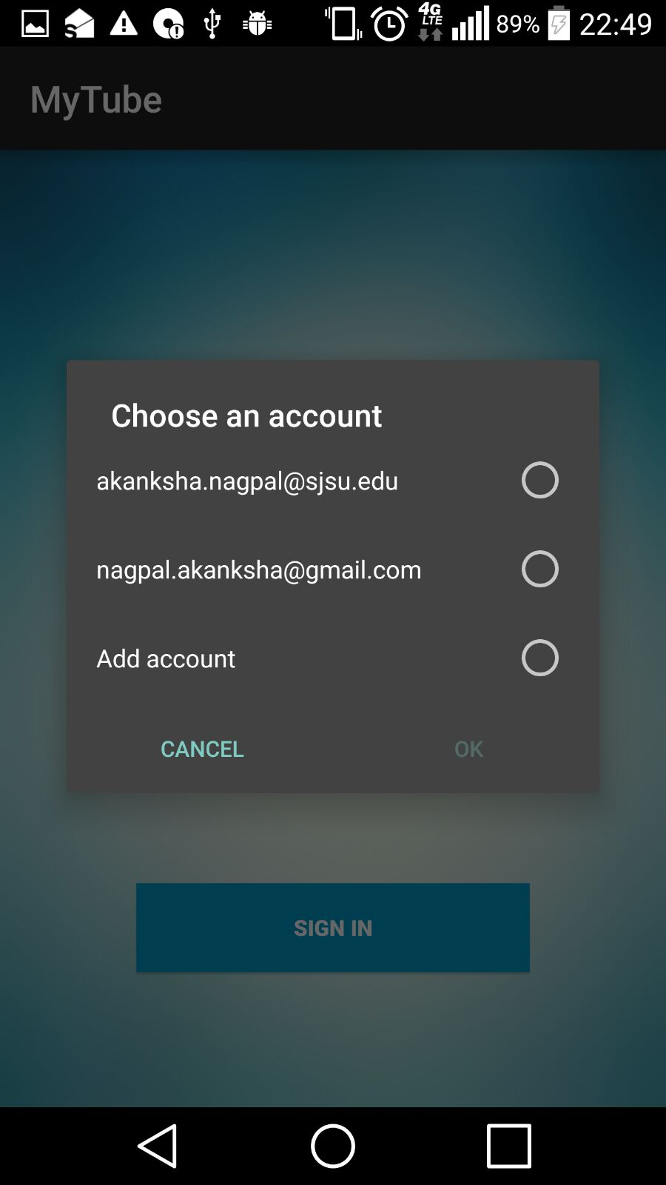

Home Screen

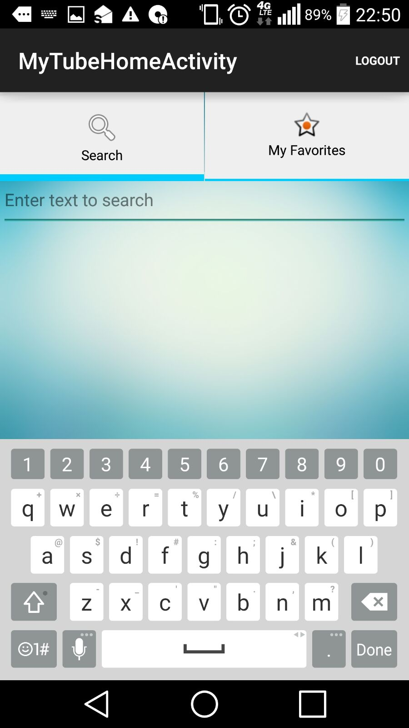

Tab View – Search Screen



Tab View – Search Results Found Screen

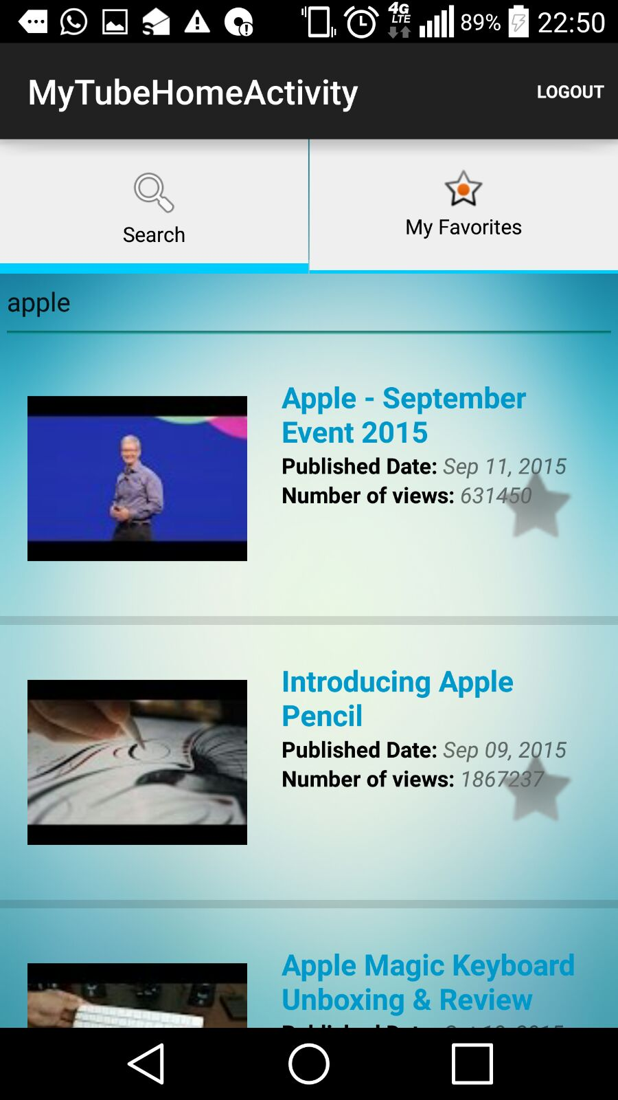

Tab View – Add to Favorite Screen

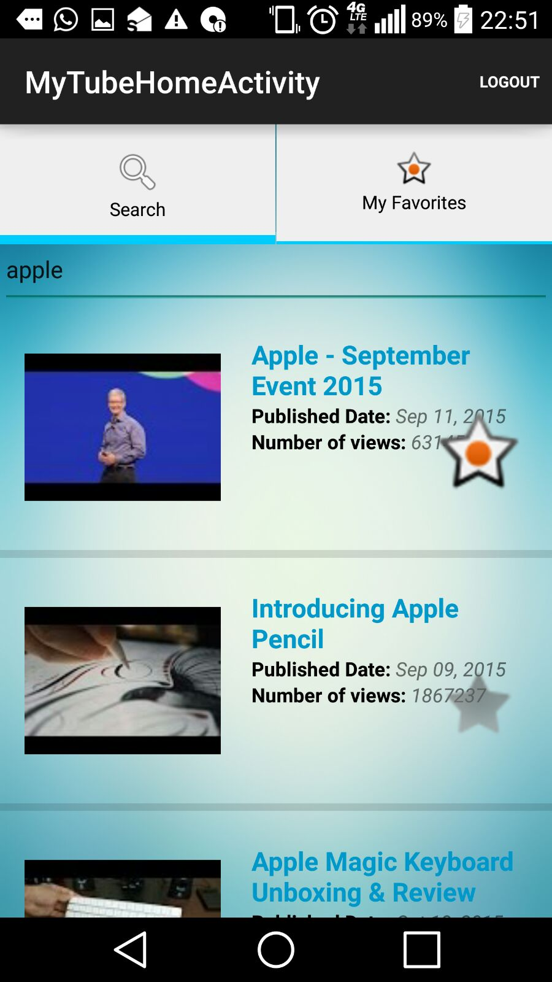

Tab View – Favorites Screen

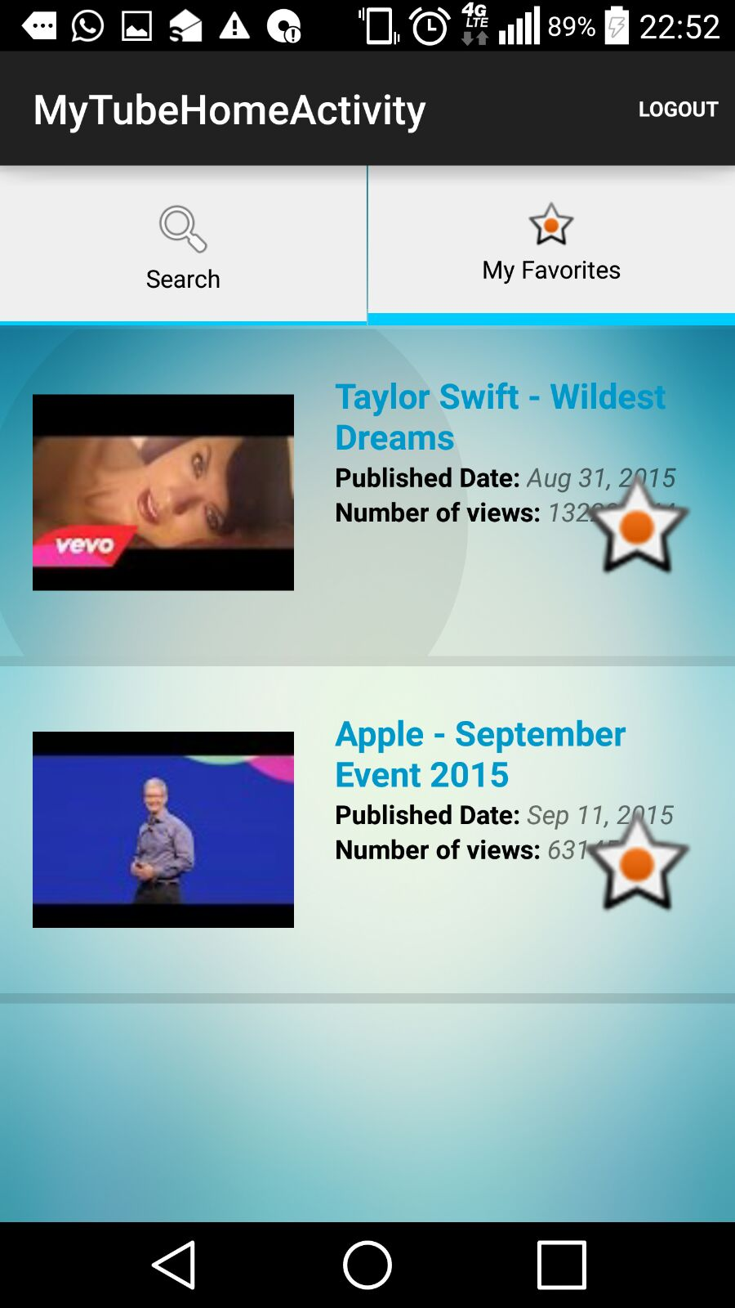

Player API Screen

